Testing From Portal to OSB
- creating new user
https://www.finnair.com/int/gb/join?_ga=1.106990722.1883898738.1470217358

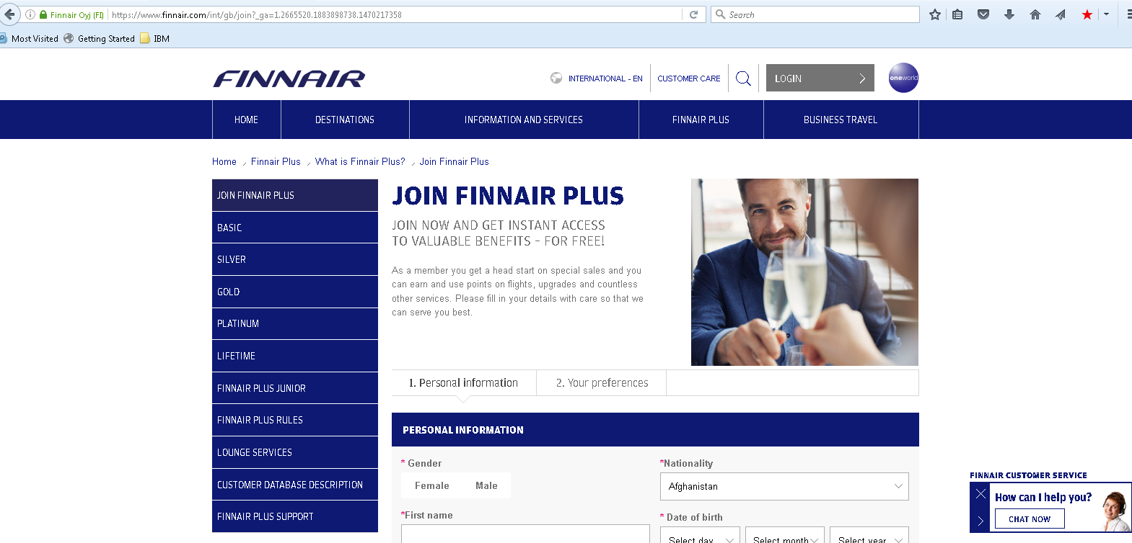

2>Update Profile
https://www.finnair.com/int/gb/plus/my-finnair-plus/update-profile
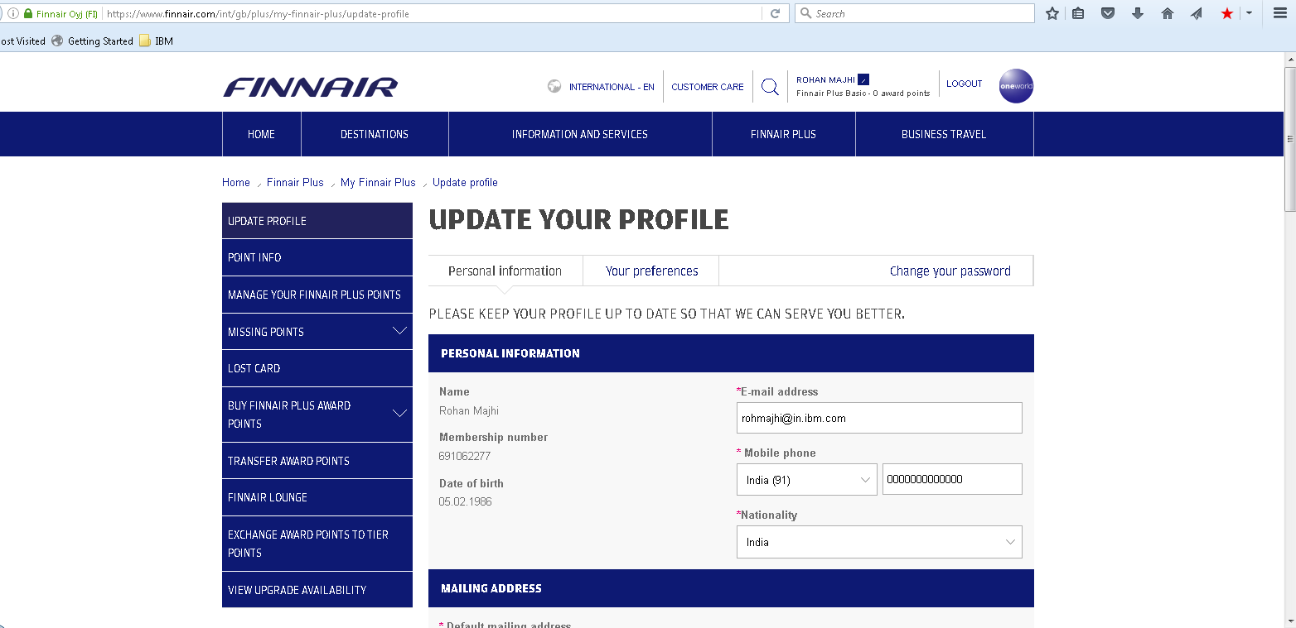

4>Corporate User Creation
https://www.finnair.com/gb/gb/corporate/enrollment?_ga=1.7520434.1883898738.1470217358

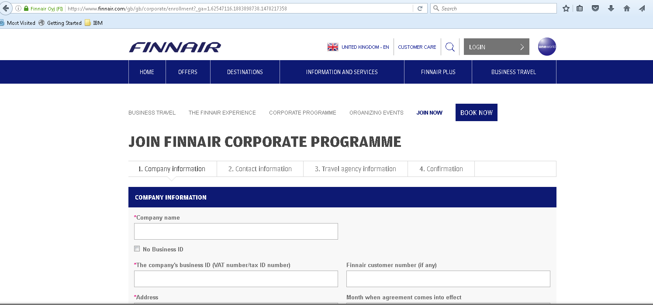

5>PointInfoRetrive
https://www.finnair.com/gb/gb/finnair-plus/my-finnair-plus/point-info
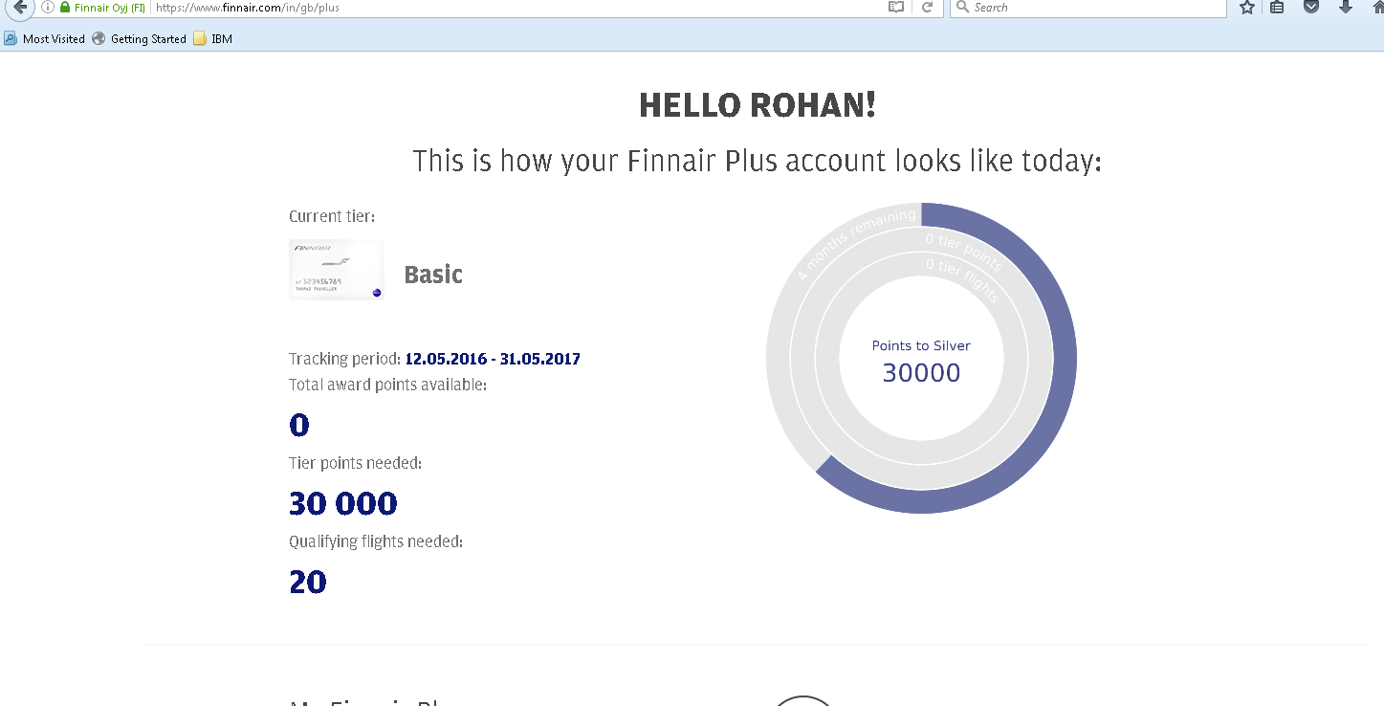

6>Missing Points Info
https://www.finnair.com/gb/gb/finnair-plus/my-finnair-plus/missing-points

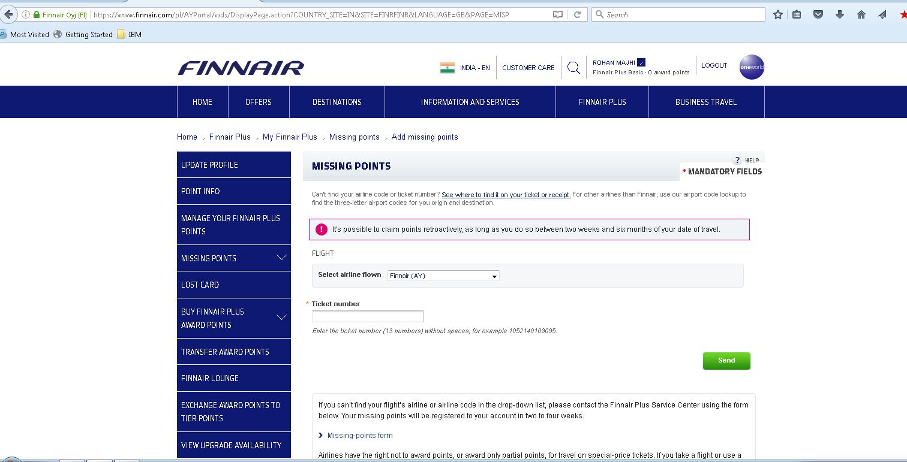

7>Availability Search
https://www.finnair.com/gb/gb/finnair-plus/view-upgrade-availability

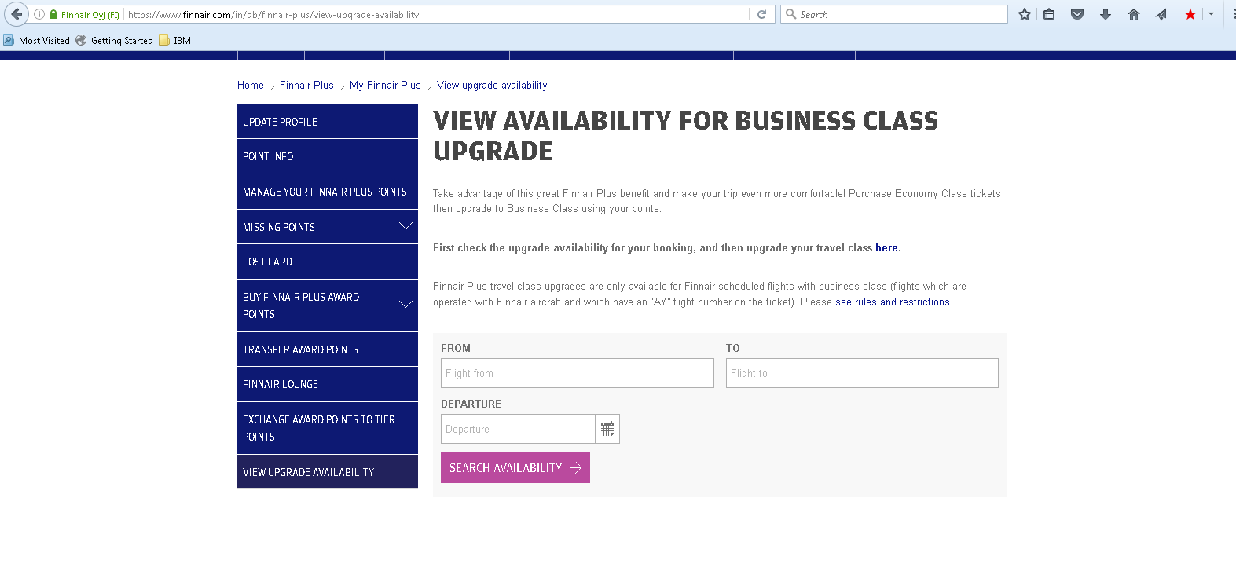

8>Feedback
https://www.finnair.com/fi/gb/information-services/feedback
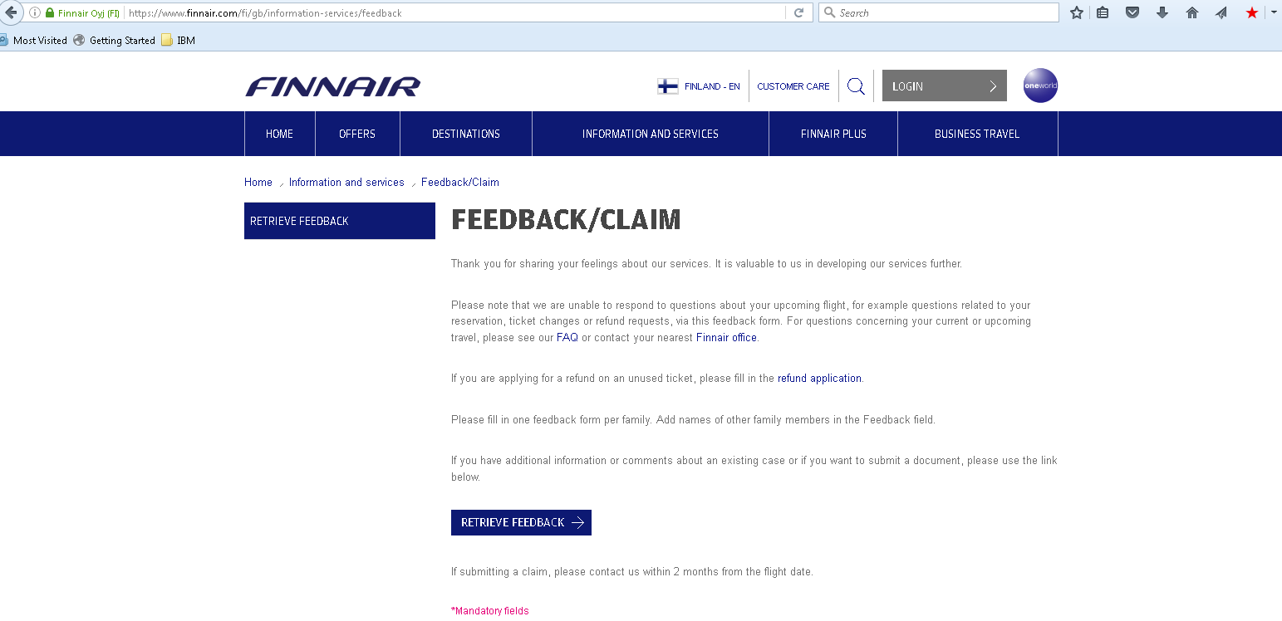
9> Booking with Award Points

https://www.finnairplusshop.com/gift-cards-vouchers-hotels-sokos-hotels-sokos-hotels-award-voucher-original-hotels

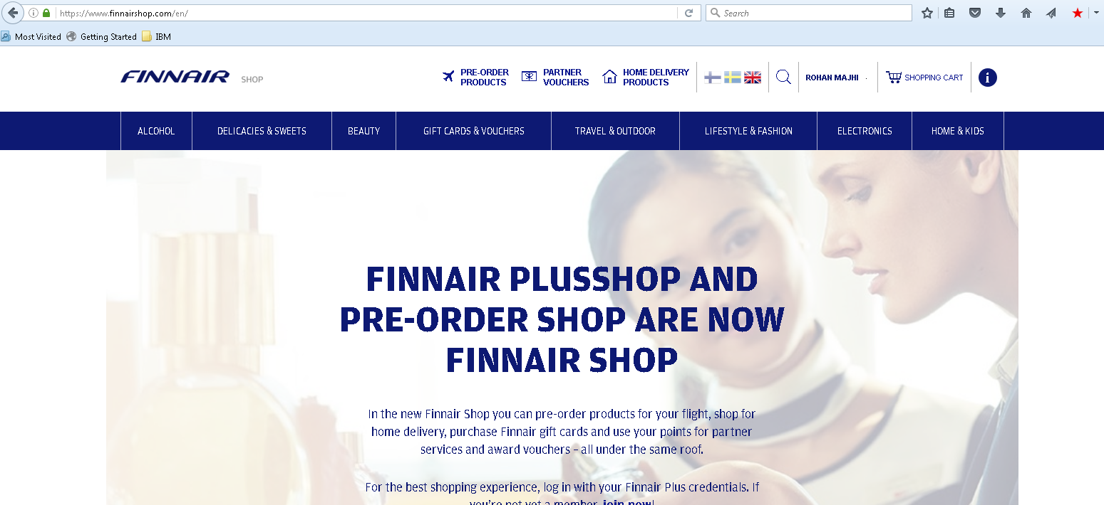
10> Booking with Award Points
https://www.finnairshop.com/en/partner-vouchers/hotels/hotels-in-finland/hotel-haven
